**1.Create a program that blinks the LED on the development board using MBED software**

**Aim:**

**To write a program for blink led using tinker Cad.**

**Components Used:**

**1.Arduino Uno**

**2.LED(Light Emitting Diode)**

**1.Get the Arduino uno board from the components**

**2.Get the LED from the components**

**3.LED has two side which is positive (anode) and Negative(Cathode).Negative side is connected to the Ground(GND).Positive side is connected to Digital pin 13 of Arduino .**

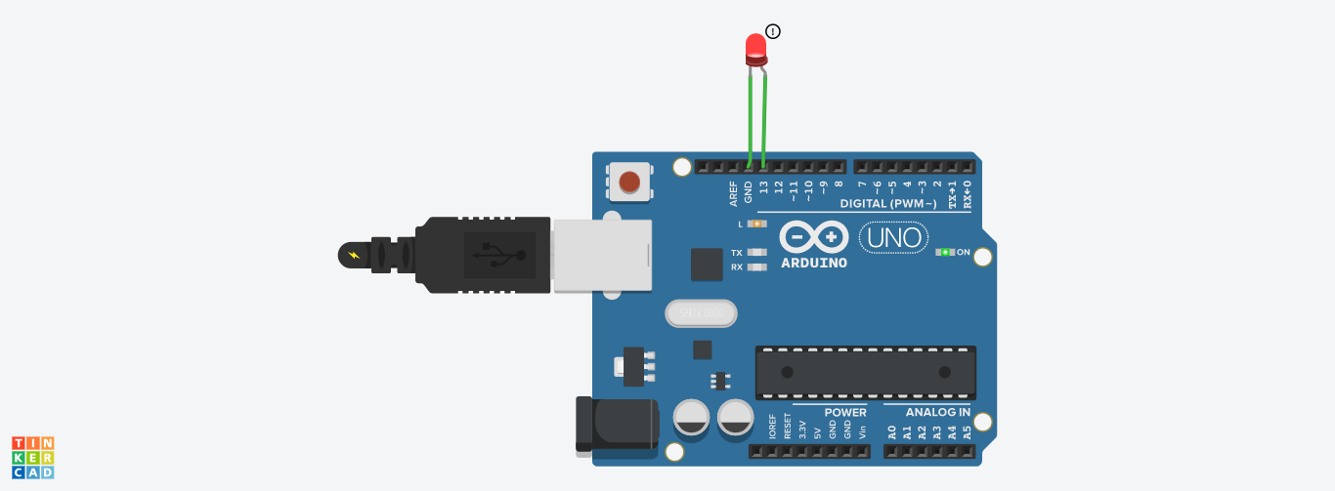

Code:

// C++ code

//

void setup()

{

pinMode(13, OUTPUT);

}

void loop()

{

digitalWrite(13, HIGH);

delay(1000); // Wait for 1000 millisecond(s)

digitalWrite(13, LOW);

delay(1000); // Wait for 1000 millisecond(s)

}

**1.2.Through Button blink LED**

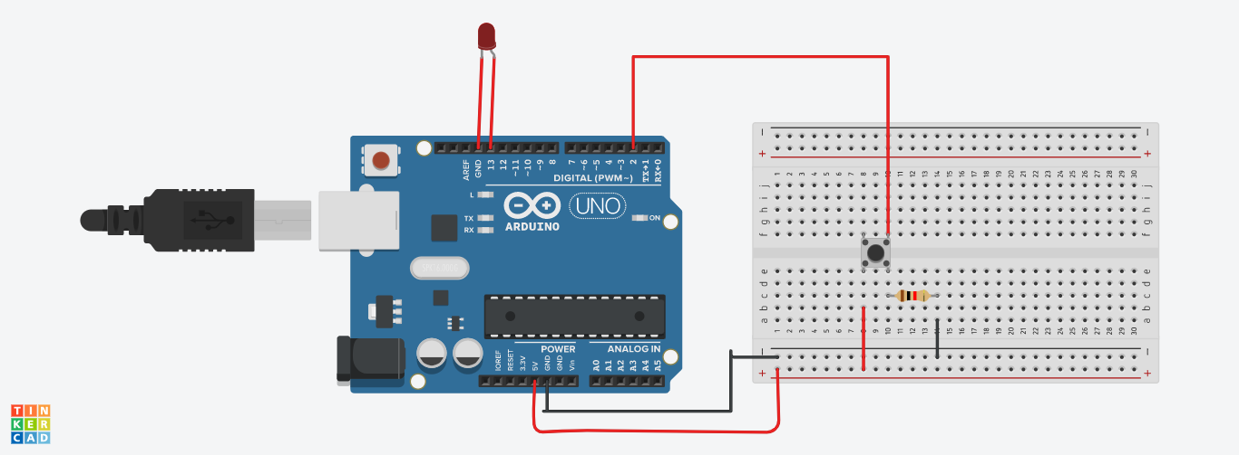

void setup()

{

pinMode(2, INPUT);

pinMode(13,OUTPUT);

}

void loop()

{

if(digitalRead(2)==1)

{

digitalWrite(13,HIGH);

}

else

{

digitalWrite(13,LOW);

}

}

**3.Analog potentio meter**

how to read analog input from the physical world using a potentiometer.

A **potentiometer** is a simple mechanical device that provides a varying amount of resistance when its shaft is turned. By passing voltage through a potentiometer and into an analog input on your board, it is possible to measure the amount of resistance produced by a potentiometer (or pot for short) as an analog value. In this example you will monitor the state of your potentiometer after establishing serial communication between your Arduino and your computer running the Arduino Software (IDE).

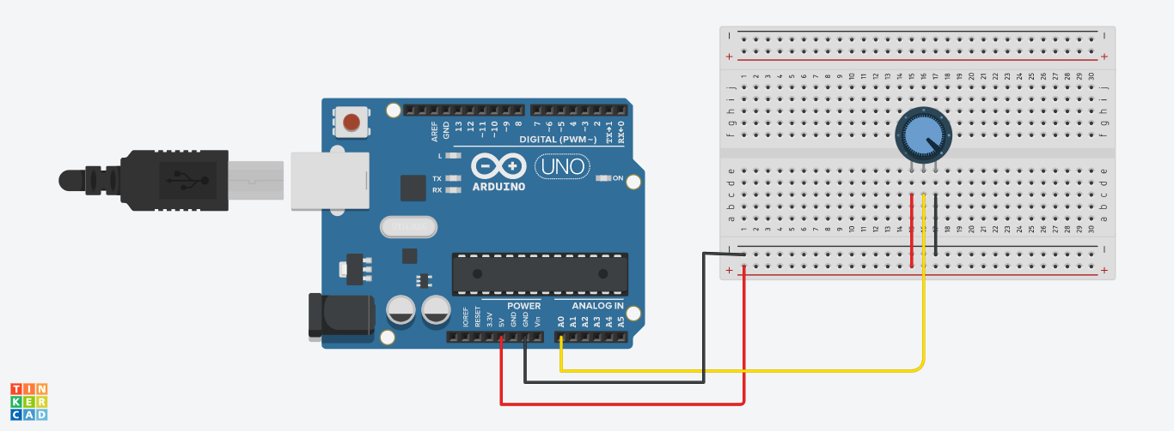

int pot=A0;

void setup()

{

Serial.begin(9600);

}

void loop()

{

int potvalue=analogRead(pot);

Serial.print("pot value");

Serial.println(potvalue);

delay(1);

}

**Output:**

pot value818

pot value777

pot value716

pot value696

pot value675

pot value675

pot value675

pot value675

pot value675

pot value675

pot value675

pot value675

pot value675

pot value675

pot value675

pot value675

pot value655

pot value614

pot value614

pot value593

pot value593

pot value573

pot value573

pot value532

pot value532

pot value532

pot value532

pot value511

pot value511

pot value491

pot value471

pot value471

pot value471

pot value471

pot value450

pot value450

pot value450

pot value368

pot value61

pot value41

pot value20

pot value20

pot value20

pot value20

pot value20

pot value0

4.Reading Sensors

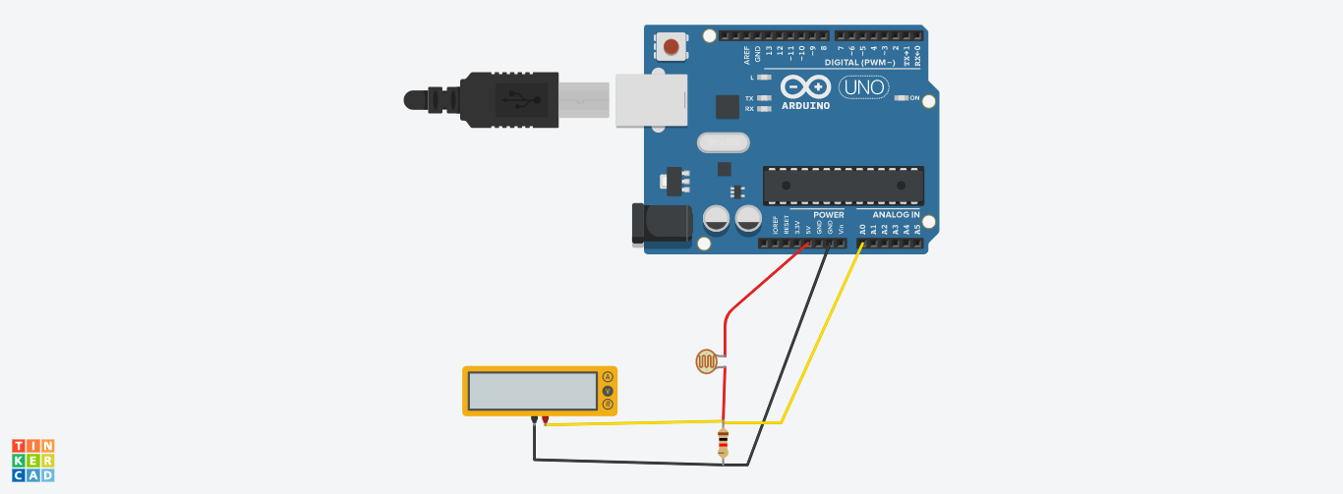

void setup()

{

pinMode(A0, INPUT);

Serial.begin(9600);

}

void loop()

{

int lightvalue=analogRead(A0);

Serial.println(lightvalue);

delay(1000);

}

Output:

6

6

379

526

640

658

663

654

476

6

6

6

6

6

6

6

6

6



Send

Clear